Pigeon Racing System — Design Document v3.0
Oct 30, 2026 · @Silvio Ariclenes Antonio Feio
Pigeon Pairing & Performance Tracker (WinNest)
A digital breeding and performance record system for competitive pigeon racing
Prepared for: Gerard Koopman
Prepared by: Osinavhe Akhigbe, Silvio Ariclenes António Feio, Rodrigo de Araújo Castanheira, Caleb Gaïtou
NHL Stenden University of Applied Sciences, Emmen
Course: Project Year 2 — Group IT2D
Version: 3.0
Date: 30-10-2026

Version History
Table 1 – Version history
Version | Date | Author | Changes
1.0 | 24-09-2026 | Project group IT2D | First version, based on the project plan, the meeting of 8 September and the team notes.
1.1 | 24-09-2026 | Project group IT2D | Simpler language; the main gap (no tracking for international birds) added.
1.2 | 28-09-2026 | Project group IT2D | Version submitted for teacher feedback.
2.0 | 05-10-2026 | Project group IT2D | Teacher feedback of 28 September processed.
2.1 | 10-10-2026 | Project group IT2D | Formulas described in words; architecture, data flow diagram and ERD simplified.
3.0 | 30-10-2026 | Project group IT2D | Document aligned with the built system. Removed what was not built (login, Pigeons/Races/Import pages, Chart.js, adjustable dashboard filters, CompuClub export, DNA storage, multi-generation pedigree). Added the CSV import, the OneLoftRace sync, the implemented ranking formula and its fixed settings, the four pages, the setup script and the automated tests.

Table of Contents
- Introduction
- Scope
- Requirements
- Architecture
- Data Model
- Pair Ranking
- Pages, Development and Testing
- Open Questions
- References
Appendix A. Meeting of 20 September 2026

1. Introduction

1.1 Purpose of this Document
This document describes the design of the Pigeon Pairing & Performance Tracker (WinNest) as it was built. Version 3.0 aligns the design with the delivered code: parts that were planned but not built have been removed, and parts that were added during development are described. It is based on the Project Plan (04-09-2026), the client meetings of 8 and 20 September 2026, the team notes, the teacher feedback of 28 September 2026 and the project repository.

1.2 Background
The client, Gerard Koopman, was a professional pigeon racer for around 30 years. Two years ago he scaled down and sold around 600 pigeons at auction. He now mainly takes part in one-loft racing: young pigeons are bred at home and sent to one-loft races in other countries, such as Thailand, Portugal and Qatar. An entry fee is paid per pigeon; the race organisers look after the pigeons, and the client follows the results online.

1.3 Existing Systems
The new system works next to the client's CompuClub software and builds on the WinNest prototype.
CompuClub. The client uses CompuClub for pedigree registration and Dutch race results. Ring numbers and parentage are entered by hand when the pigeons are a few days old. CompuClub has no support for one-loft results from races abroad.
WinNest prototype. The first prototype of the project group: four linked web pages (Home, Rankings, Race Results and Participants) with example data, without a database.
Table 2 – What is kept from the existing systems
System | Kept | Changed or added
CompuClub | Remains the client's own system for pigeons, parentage and Dutch race results. | Nothing in CompuClub is changed. The youngsters and their parents are delivered to WinNest as a CSV file.
WinNest prototype | Page layout, colour scheme, navigation menu and the structure of the Rankings and Race Results pages. | Rebuilt as Laravel Blade views. Participants became the Breeding Pairs page; the ranking of people became a ranking of breeding pairs; example data was replaced by a database.

1.4 Problem Analysis
The client cannot see which breeding pairs produce the best one-loft racers. Table 3 shows the causes.
Table 3 – Causes and consequences of the problem
Cause | Consequence for the client
One-loft results are only available on the websites of the race organisers. | Results are scattered over several websites and are not stored anywhere the client controls.
One-loft results are not linked to the parent pair. | The link between a result and its parents only exists in the client's memory.
Youngsters of the same pair race in different races. | The full record of a pair is never visible in one place.
Survival and fertility are not recorded with the results. | Pairs that lose many youngsters, or produce few, are not recognised.
Every youngster sent abroad costs an entry fee. When pairing decisions in December and January are based on memory, weaker pairs may be kept and stronger pairs under-used.

1.5 Design Goal
The system links the client's youngsters to their parent pairs, collects their one-loft results in one database, and ranks the breeding pairs on their youngsters' race performance, fertility and survival.

2. Scope

2.1 In Scope (built)
- Storing pigeons: ring number, sex, colour, parent pair and survival status.
- Importing youngsters, their parents, races and results from CSV files.
- Creating breeding pairs per season automatically from each youngster's father and mother.
- Storing one-loft races and their stages (training, Hot Spot Race, final) with the number of participants.
- Fetching the client's results automatically from oneloftrace.live for linked races.
- Storing fertility per pair (eggs laid, fertile, hatched, weaned).
- Ranking the breeding pairs on performance, fertility and survival.
- Four read-only pages: Home, Pair Rankings, Race Results and Breeding Pairs.
- A one-command setup script and automated tests.

2.2 Out of Scope
- Forms for entering or editing data on the website; data is loaded through the import and sync commands.
- A login; the system runs locally for a single user.
- Charts, and changing the ranking weights on the website.
- Integration with national pigeon federation databases.
- A native mobile app.
- Changing data in CompuClub, or reading CompuClub directly.
- Storing DNA verification results.
- Home (Dutch) race results; these stay in CompuClub.

2.3 Assumptions
- Every youngster sent to a one-loft race is listed with its father and mother in the entries CSV.
- One-loft results show at least the ring number and the position of each pigeon.
- Ring numbers can be written in different ways ("NL 24-8077898", "8077898/24"); the system brings them to one format ("24-8077898").

2.4 Constraints
- All deliverables are due in week 8 of the course.
- The system runs in the NHL Stenden PHP Docker environment.
- The oneloftrace.live data comes from public, undocumented endpoints that can change without notice.
- The system works alongside CompuClub and does not replace it.

3. Requirements

3.1 Sources
Table 4 – Sources of the requirements
Source | Date | Used for
Project Plan | 04-09-2026 | Scope, epics, success criteria
Client meeting (minutes) | 08-09-2026 | Background, current process, pigeon and race information
Client meeting (Appendix A) | 20-09-2026 | Requirements for international racing
Team notes | 08-09-2026 | Combining pedigree data with race results; ranking on performance and fertility

3.2 User Stories
Table 5 lists the user stories that were built and how the system meets each one. The role is always the client, a breeder who sends youngsters to one-loft races.
Table 5 – User stories and how they are met
ID | User story | How it is met
US-01 | As a breeder, I want my youngsters stored with their ring number, sex, colour and parents, so that every youngster can be traced back to its parents. | import:pigeons reads race_entries.csv and parents.csv.
US-02 | As a breeder, I want to load my youngsters and their parents from a file, so that I do not have to enter them twice. | Same import; it can be run again and only adds or updates rows.
US-03 | As a breeder, I want to know which birds are paired in which season, so that results are counted for the right pair. | The import creates one pair per father, mother and season.
US-04 | As a breeder, I want each youngster linked to its parent pair, so that I can see which pair it comes from. | Breeding Pairs page: list of all youngsters with their pair.
US-05 | As a breeder, I want one-loft races stored with their country, season and stages, so that results from different races are stored in the same way. | races.csv, plus stages created by the import and the OneLoftRace sync.
US-06 | As a breeder, I want my youngsters' results in training flights, Hot Spot Races and finals in one place. | results.csv and the olr:sync command; shown on the Race Results page.
US-07 | As a breeder, I want the results of youngsters from the same pair combined, even when they raced in different races. | The ranking groups all results by parent pair.
US-08 | As a breeder, I want to know whether a youngster is still alive, so that losses count in the judgement of a pair. | status and status_date on each pigeon; currently filled with demo data.
US-09 | As a breeder, I want the fertility of each pair recorded, so that productive pairs can be recognised. | Fertility record per pair; currently filled with demo data.
US-10 | As a breeder, I want a ranking of my breeding pairs based on their youngsters' performance, fertility and survival. | Pair Rankings page (chapter 6).
US-11 | As a breeder, I want to open a pair and see the youngsters and results behind its score. | Breeding Pairs page: pair profile with rank, scores, youngsters and results.
US-12 | As a breeder, I want my results fetched from the race website, so that I do not have to copy them by hand. | olr:sync fetches results from oneloftrace.live. Added during development.

3.3 Pigeon Information
Table 6 – Pigeon information
Field | Description
Ring number | Unique identification, stored in one format ("24-8077898")
Sex | Cock, hen or unknown
Colour | Colour of the pigeon (optional)
Parent pair | The breeding pair the youngster comes from; empty for parents
Status | Alive or lost, with the date
Hatch year | Not stored; read from the ring number

3.4 Race Information
A one-loft race consists of training flights, Hot Spot Races (the races before the final) and a final. For each stage, the system stores its name, its type, the number of pigeons that took part, and the position of each of the client's pigeons. A semi-final counts as a Hot Spot Race.

4. Architecture

4.1 Architecture and Data Flow
WinNest is a Laravel web application with a MySQL database. Data is loaded by three Artisan commands; the four web pages only read it. Figure 1 shows the parts and the direction the data flows.
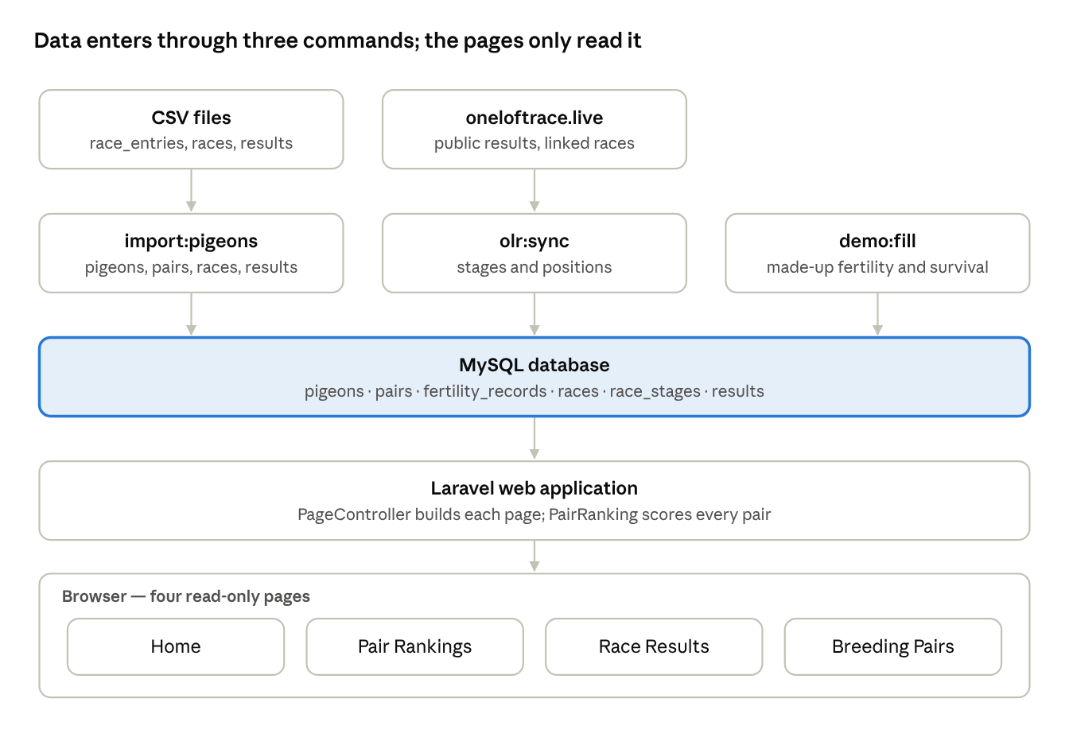
Figure 1 – Architecture and data flow of WinNest
- Commands: import:pigeons reads the CSV files; olr:sync fetches results from oneloftrace.live; demo:fill adds made-up fertility and survival numbers for demonstrations (demo:fill --reset removes them).
- Web application: PageController collects the data for each page; PairRanking calculates the scores.
- Database: stores pigeons, pairs, fertility, races, stages and results.
- Browser: the pages, built as Blade views on the WinNest prototype design.

4.2 Data Acquisition
Table 7 – How data gets into the system
Data | Method | Notes
Youngsters and parents | race_entries.csv (ring, sex, colour, father, mother, race) and optional parents.csv (colours of parents) | 90 youngsters from 38 pairs in two races.
Races | races.csv (name, organiser, country, season) | Mira One Loft Race 2026 and Algarve Pigeons Golden Race 2026.
Results | results.csv (ring, race, stage type, stage name, participants, position) | Manual results, for races or stages not on oneloftrace.live.
Results | olr:sync reads the public JSON endpoints of oneloftrace.live | A race is linked once with its OneLoftRace season id. Finished flights are fetched once; running flights every time. Only pigeons of the team "Koopman" are stored. --dry-run shows changes without saving.
Fertility and survival | demo:fill (demo data only) | Real numbers still have to come from the client (Q-03).
The import runs in one transaction: if a file is wrong, nothing is saved. Rows with an unknown pigeon, race, stage type or impossible position are skipped and listed as warnings.

4.3 Technology
Table 8 – Technology used
Component | Choice | Used for
Front-end | HTML and CSS in Laravel Blade views | The four pages, based on the WinNest prototype
Back-end | PHP 8 with Laravel | Routing, database models, Artisan commands, HTTP client
Database | MySQL | Storing pigeons, pairs, races, results and fertility
Environment | NHL Stenden PHP Docker environment | Running PHP and MySQL locally
Setup | setup.sh | One command that installs packages, creates .env, migrates the database, imports the CSVs and syncs OneLoftRace. Safe to run again.
Testing | PHPUnit | Automated tests (section 7.3)
Version control | Git and GitHub | Feature branches and pull requests

5. Data Model

5.1 Entity Relationship Diagram
The database has six tables. Figure 2 shows them with the fields used by the system. Compared with version 2.1, the OneLoftRace ids (olr_season_id, olr_flight_id, olr_synced_at) were added, and sex can also be "unknown".
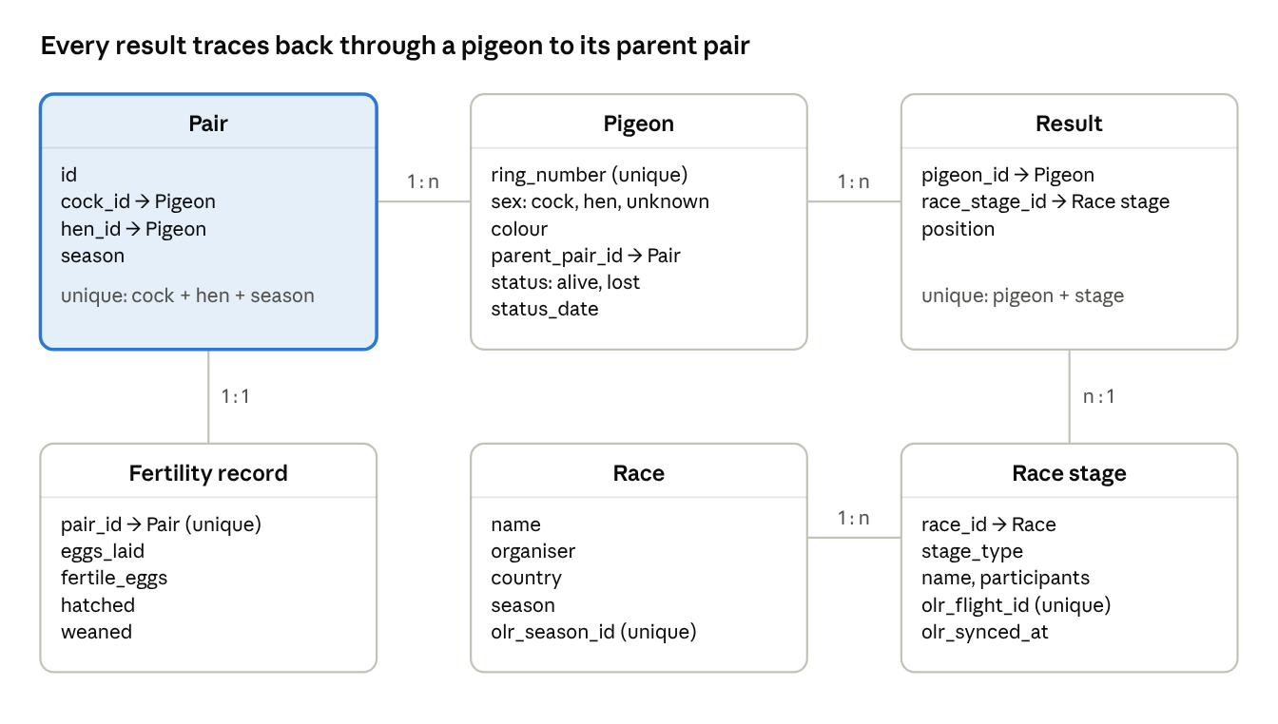
Figure 2 – Entity relationship diagram (as built)
A pair has two links to Pigeon: its cock and hen (the parents), and its youngsters through parent_pair_id. A parent that is part of a pair cannot be deleted.

5.2 Entities
Table 9 – Entities
Entity | Description
Pigeon | Any pigeon of the client, parent or youngster. Identified by its ring number. A youngster has a parent pair; a parent has none.
Pair | A cock and a hen paired in one season. Created automatically by the import.
Fertility record | Eggs laid, fertile eggs, hatched and weaned youngsters of one pair.
Race | A one-loft race, with its organiser, country and season, and optionally its OneLoftRace season id.
Race stage | One training flight, Hot Spot Race or final within a race, with the number of participants.
Result | The position of one pigeon in one race stage.

5.3 Check Against the Ranking
Table 10 – Ranking inputs and where they are stored
Ranking input | Stored in
Youngsters of a pair | pigeons.parent_pair_id
Position in a stage | results.position
Number of participants in a stage | race_stages.participants
Type of stage | race_stages.stage_type
Fertility | fertility_records.eggs_laid, fertility_records.weaned
Survival | pigeons.status

6. Pair Ranking
The ranking uses formula F-C from version 2.1: a weighted total of performance, fertility and survival. It is calculated by the PairRanking service each time a page is opened. Every score runs from 0 to 1. The simpler candidates F-A and F-B were not built.

6.1 How the Score is Calculated
Each pair gets a score from three parts, shown in Table 11. A part without data counts as 0.
Table 11 – Parts of the pair score
Part | How it is calculated | Weight
Performance | For every result of the pair's youngsters: how high the youngster finished compared with the number of participants (1st place = 1, last place ≈ 0). Finals count 3×, Hot Spot Races 2× and training flights 1×. The pair gets the average. | 60%
Fertility | Weaned youngsters ÷ eggs laid | 20%
Survival | Youngsters still alive ÷ all youngsters | 20%
Example: a youngster that finishes 17th of 1,817 pigeons in a final scores about 0.99, because almost all pigeons finished behind it.

6.2 Settings
The settings are fixed in the code; they cannot be changed on the website.
Table 12 – Ranking settings
Setting | Value | Open question
Weight of performance / fertility / survival | 0.6 / 0.2 / 0.2 | Q-04
Stage weight: training / Hot Spot Race / final | 1 / 2 / 3 | Q-05
Minimum number of youngsters | 2; pairs with fewer are marked with * | Q-09
The values are the project group's starting values and still have to be confirmed by the client.

6.3 Where the Ranking is Shown
The Pair Rankings page shows every pair, best first, with its season, number of youngsters, the three part scores and the total. The Breeding Pairs page shows one pair's rank and scores together with its youngsters and their results (US-11). The ranking is tested against a hand-calculated example (section 7.4).

7. Pages, Development and Testing

7.1 Pages
The website has four read-only pages, linked by the navigation menu of the WinNest prototype.
Table 13 – Pages
Page | Shows | User stories
Home | Number of breeding pairs, races and youngsters; every race with its number of stages and the client's best youngster in the final. | US-05, US-06
Pair Rankings | All pairs, best first, with youngsters, performance, fertility, survival and total score. | US-07, US-10
Race Results | A race chosen from a list; the client's results in it, finals first, with position, youngster, parent pair, participants and top percentage; the time of the last OneLoftRace sync. | US-05, US-06, US-12
Breeding Pairs | A pair chosen from a list (ordered by rank): its rank, scores, fertility, youngsters and their results; below it, all youngsters with their pair, sex, colour, hatch year and number of results. | US-01, US-03, US-04, US-08, US-09, US-11

7.2 Functions per Epic
Table 14 – Functions per epic
Epic | Function as built | Where
Bird registration | Import youngsters and parents from CSV | import:pigeons
Pairing management | Pairs created per father, mother and season | import:pigeons
Offspring tracking | Youngsters linked to their pair; survival status | Breeding Pairs page
Race result logging | Races, stages and results from CSV and OneLoftRace | import:pigeons, olr:sync, Race Results page
Fertility | Fertility record per pair (demo data for now) | demo:fill, Breeding Pairs page
Reporting | Pair ranking with the details behind each score | Pair Rankings and Breeding Pairs pages

7.3 Development History
Table 15 – Main changes in the repository
Date | Change
30-10-2026 | setup.sh added; security fixes after code review
27-10-2026 | OneLoftRace sync added, with fixes throughout the code
26-10-2026 | Breeding pairs and ranking pages read from the database; demo data added
23-10-2026 | CSV importer for pigeons, pairs, races and results
20-10-2026 | Login removed
18-10-2026 | Database tables and models, test data seeder, ranking calculation, prototype pages as Blade views

7.4 Testing
The system is tested with PHPUnit.
Table 16 – Automated tests
Test | Checks
PairRankingTest | Scores match a hand-calculated example; a stage with 0 participants does not crash; a parent in a pair cannot be deleted
ImportPigeonsTest | The import creates the pigeon, its parents and its result; a re-import keeps a "lost" status
SyncOneLoftRaceTest | The sync links a CSV stage, stores only known pigeons and is safe to run again; a failed fetch writes nothing; a dry run saves nothing
PagesTest | Every page loads with data; results show the final first, then stages in natural order
RingTest | Ring formats from CSV and OneLoftRace become the same; the hatch year is read from both ring styles

8. Open Questions
Q-01 (CompuClub export), Q-02 (which races) and Q-07 (DNA results) are closed: the system uses CSV files, the races are the Mira One Loft Race and the Algarve Pigeons Golden Race, and DNA results are out of scope. Table 17 lists the questions that are still open.
Table 17 – Open questions
ID | Question | Affects
Q-03 | How does the client measure the fertility of a pair, and can he supply the real numbers? | Fertility (now demo data)
Q-04 | Are the weights 0.6 / 0.2 / 0.2 for performance, fertility and survival right? | Chapter 6
Q-05 | Are the stage weights 1 / 2 / 3 for training, Hot Spot Race and final right? | Chapter 6
Q-06 | How should a youngster that is lost during a race count? | Survival (now demo data)
Q-08 | How many seasons should the ranking cover? | Chapter 6
Q-09 | Is a minimum of 2 youngsters enough to judge a pair fairly? | Chapter 6
Q-10 | Has the client confirmed in writing the summary of the meeting of 20 September? | Appendix A

9. References
- Project Plan — Pigeon Pairing & Performance Tracker, 04-09-2026.
- Minutes of project meeting — Introduction & requirements discussion, 08-09-2026.
- Minutes of project meeting — 20-09-2026 (Appendix A).
- Team notes taken during the client meeting of 08-09-2026.
- Teacher feedback on Design Document v1.2, 28-09-2026.

